Magpie Project Task #2 Chatbot Modification

1. Provide a screen shot here of the required modifications detailed in the Exercises section of Activity 2. Provide screen shots of the code and evidence that your chatbot responds as intended.

1. The following changes would have been made:
2. Have it respond to "Tell me more about your pets."
3. Have it respond favorably when it sees the name of your teacher.
4. Have the code check that the statement has a least one character.
5. Add a two noncommittal response to the random responses.
6. Pick three more keywords to add to the getResponse method.

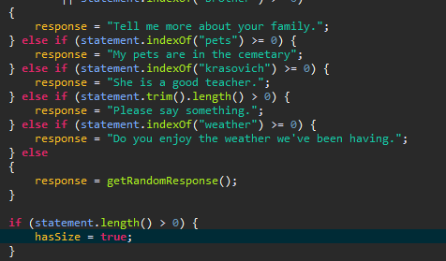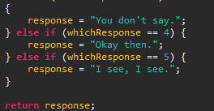

2. What happens when more than one keyword appears in a string? Consider the string "My mother has a dog but no cat." Explain how to prioritize responses in the reply method.

It will choose the response of the first one found; to change priority, change the location in the if . . . else statement.

3. What happens when a keyword is included in another word? consider statements like "I know all the state capitals" and "I like vegetables smothered in cheese." Explain the problem with the responses to these statements.

It will find the word in the word that matches a keyword and respond to that keyword.

|  |  |  |  |  |
| --- | --- | --- | --- | --- |
| 50-59% | 60-69% | 70-79% | 80-89% | 90-100% |
| At least one of the modifications were attempted.  At least one of the questions were answered. | Less than half of the modifications were attempted.  Some of the questions have relevant responses. | Most modifications were attempted.  Some questions have relevant responses and some are explained. | All required modifications were attempted.  All questions have thorough and relevant responses and are explained. | All required modifications were made as directed.  All questions have thorough, relevant and expertly explained responses. |